FINALTERM EXAMINATION
FIN622- Corporate Finance (Session - 1)

Question No: 1 ( Marks: 1 ) - Please choose one
A project would be financially feasible in which of the following situations?

► If Internal Rate of Return of a project is greater than zero
► If Net Present Value of a project is less than zero
► If the project has Profitability Index less than one
► If the project has Profitability Index greater than one

Ref: (BOOK FM) PAGE # 42
Those projects with a profitability index ratio of more than one (PI >= 1.0) are considered
Question No: 2 ( Marks: 1 ) - Please choose one
Which one of the following statements applies to Dividend Growth Model?

► It is difficult to understand and use
► It is used for non-listed companies
► It is used for debt securities also
► It do not consider risk level of a security

Ref: PAGE # 60
This approach does not take into account the risk level. There is no direct adjustment for the risky ness of the investment. For instance, there is no adjustment for the degree of certainty or uncertainty in estimated growth rate for dividends

Question No: 3 ( Marks: 1 ) - Please choose one
Which of the following statements is true regarding Weighted Average Cost of Capital (WACC)?

► WACC of a levered firm is greater than that of an un-levered firm
► WACC of a levered firm is lesser than that of an un-levered firm
► WACC of a levered firm is equal to that of an un-levered firm
► An Un-levered firm has zero WACC.

Ref: PAGE # 71
The after tax cash flow of two identical firms in terms of EBIT but having
different capital structure – debt – equity weight age will effect the value of firm. This is because debt in capital structure provides tax shield as interest on debt is tax deductible expense. Thus tax shield increases the value of firm: a levered firm’s value is greater than the un-levered firm.

Question No: 4 ( Marks: 1 ) - Please choose one
Which of the following risks is independent of capital structure of a firm?

► Financial risk
► Systematic risk
► Business risk
► Total risk

Ref: http://www.slideshare.net/piyooshtripathi/capital-structure-theory
Slide number 16 of above link
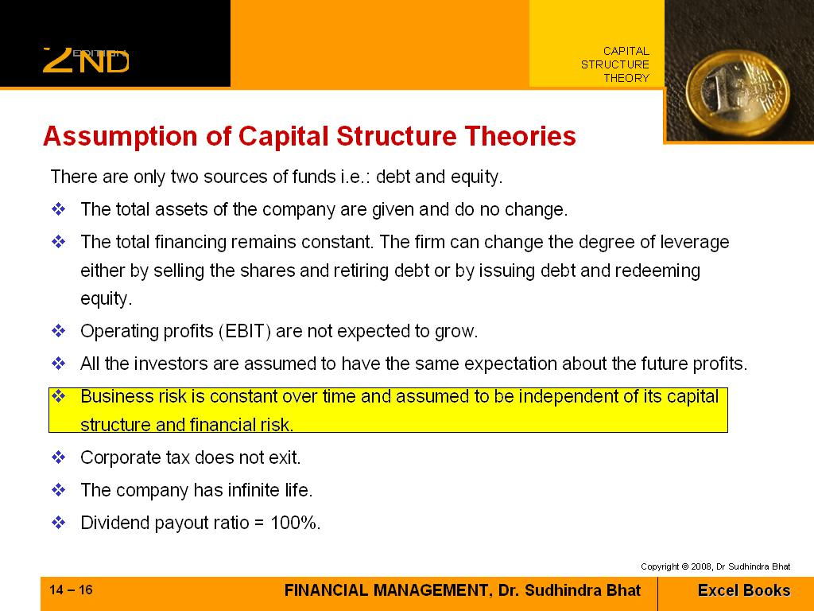
Question No: 5
Which of the following is a dividend that is paid in the form of additional shares, rather than a cash payout?

► Stock Dividend
► Cum Dividend
► Ex Dividend
► Extra Dividend

Ref: PAGE # 75
Dividend:
A taxable payment declared by a company's board of directors and given to its shareholders out of the company's current or retained earnings, usually quarterly. Dividends are usually given as cash (cash dividend), but they can also take the form of stock (stock dividend) or other property.

Question No: 6 ( Marks: 1 ) - Please choose one
In which of the following situations, a company has the ability to pay off its short-term obligations easily?

► If the company has a positive working capital
► If the company has a negative working capital
► If the company has a zero working capital
► None of the given option

Ref: http://www.ehow.com/how_4421978_calculate-working-capital.html
Working capital is often used as a barometer to measure a company's over health and liquidity. If a company has negative working capital, it means that the current liabilities are greater than the current assets. This may mean that the company may have trouble paying off it's short-term obligations. This can impact the overall efficiency of the company because the company may not be able to spend as aggressively as its competitors. Investors often watch working capital closely to check on the financial health of a company.
And
If a company has ample positive working capital, then they are in good shape with plenty of cash on hand to pay for everything they might need to buy. If a company has negative working capital, then their current liabilities are actually greater than their current assets and they lack the ability to spend
http://www.fool.com/Features/1996/sp0708a.htm

Question No: 7 ( Marks: 1 ) - Please choose one
In the formula Q = , “I” denotes which of the following?

► Initial cash out flow
► Interest cost of holding cash
► Investment required
► Initial investment

Ref: PAGE # 95
Q = √ 2 FS / i
Where:
S = is the amount of cash to be used in each period
F = fixed cost of obtaining new funds
i = interest cost of holding cash
Q = quantity of cash to be held per period.

Question No: 8 ( Marks: 1 ) - Please choose one
Keeping all other things constant, an increase in storage cost will result ________ in the EOQ (Economic Order Quantity).

► A decrease
► No change
► An increase
► Cannot be told without additional information

Note: Storage Cost = Carrying cost = Holding cost
Ref: see below McQ from this link http://www.chatarea.com/ethiopia.m820054
42. Which of the following statements about the basic EOQ model is true?
a. If the ordering cost were to double, the EOQ would rise.
b. If annual demand were to double, the EOQ would increase.
c. If the carrying cost were to increase, the EOQ would fall.
d. If annual demand were to double, the number of orders per year would decrease.
e. All of the above statements are true.
Question No: 9 ( Marks: 1 ) - Please choose one
Which of the following is a re-structuring strategy in which employees buy a majority share in their own firm?
► Employee Dividend Scheme
► Employee Buyout
► Employee Empowerment
► Leverage Buyout

Ref: PAGE # 124
Employee Buyout – EBO
A restructuring strategy in which employees buy a majority stake in their own firms. This form of buyout is often done by firms looking for an alternative to a leveraged buyout. Companies being sold can be either healthy companies or ones that are in significant financial distress

Question No: 10 ( Marks: 1 ) - Please choose one
All of the following could be an outcome of financial distress of a firm EXCEPT:

► Employees are leaving the firm
► Suppliers refuse to supply on credit
► Banks do not provide loans
► Financial markets become instable

Ref: http://www.investorwords.com/7302/financial_distress.html
Tight cash situation in which a business, household, or individual cannot pay the owed amounts on the due date. If prolonged, this situation can force the owing entity into bankruptcy or forced liquidation. It is compounded by the fact that banks and other financial institutions refuse to lend to those in serious distress. When a firm is under financial distress, the situation frequently sharply reduces its market value, suppliers of goods and services usually insist on COD terms, and large customer may cancel their orders in anticipation of not getting deliveries on time

Question No: 11 ( Marks: 1 ) - Please choose one
A firm can fix effective interest rate on short-term borrowings by doing which of the following?

► Buying a forward rate agreement
► Selling a forward rate agreement
► Borrowing local currency
► Borrowing base currency

Ref: PAGE # 137
Forward rate agreement(FRA)
FRA offer companies the facility to fix future interest today either on short-term borrowing or deposit for an agreed future period.
An effective interest rate can be fixed on future short-term borrowing by buying an FRA.
Alternatively,
An effective interest rate can be fixed on short-term deposit or investment by selling FRA.

Question No: 12 ( Marks: 1 ) - Please choose one
In the long run, a successful acquisition is one that:

► Enables the acquirer to make an all-equity purchase, thereby avoiding additional financial leverage
► Enables the acquirer to diversify its asset base
► Increases the market price of the acquirer's stock over what it would have been without the acquisition
► Increases the financial leverage of the firm

Ref:
Increased revenue or market share: This assumes that the buyer will be absorbing a major competitor and thus increase its market power (by capturing increased market share) to set prices.

http://en.wikipedia.org/wiki/Mergers_and_acquisitions

Question No: 13 ( Marks: 1 ) - Please choose one
Which of the following formulas can be used to calculate the value of the firm while considering merger/acquisition?
► Value of all-equity financed firm + FV of tax benefits + Expected Bankruptcy Costs
► Value of all-equity financed firm + PV of tax benefits + Expected Bankruptcy Costs
► Value of all-equity financed firm + tax benefits + Expected Bankruptcy Costs
► Value of all-equity financed firm + Expected Bankruptcy Costs

Ref: PAGE # 116
Value of firm = Value of all-equity financed firm + PV of tax benefits + Expected Bankruptcy Costs

Question No: 14 ( Marks: 1 ) - Please choose one
Which of the following effects should be considered by a firm if it allows credit to its customers?

► Cost of discount
► Arrange loans to finance short term operations
► Prices of goods
► All of the given options

Ref: PAGE # 103

Analyzing Credit Policy:
When a firm allows credit to its customers there are some effects that should be considered.
First, allowing credit to customers means that the revenues to the firm will be delayed. A firm may charge higher prices to the customers for allowing them on credit and this will result in increased sales. Total revenues may increase but still the company will receive it late. Secondly, if the company allows credit to customers and then offers cash discounts for early payment from debtors it will incur cost of discount. In other words, it is reducing its profits. After allowing credit to parties the firm must arrange some loans to finance its short term operations. Such finances do carry a handsome interest rate and this need to be considered. Increasing sales by allowing generous credit to customers also increased the probability of default and thus may incur bad debts.

Question No: 15 ( Marks: 1 ) - Please choose one
Which of the following is generally the objective of the firms behind offering discount to customers?

► To improve the cash flow
► To increase the bad debts
► To improve return on equity
► To improve the PE ratio

Ref: PAGE # 106
The motive behind offering discount to customers may have different secondary meaning to the firm. However,
The main objective is to improve the cash flow. Other may include increasing the sales as the discounts directly affect the cost of sales of customer and customer may place enhanced order, thus increasing the turnover.

Question No: 16 ( Marks: 1 ) - Please choose one
Which of the following types of dividend policies results in the most volatile dividend payments and stock holder discomfort?

► Target dividend-payout policy
► Low-regular-and-extra dividend policy
► Regular dividend policy
► Constant payout-ratio dividend policy

Ref: PAGE # 74

Constant dividend payout (div per share/Eps)
A fixed %age is paid out as dividend. Under this policy the dividend amount will vary because the
net income is not constant. Thus results in variability of return to investors. The dividends may drop to nil in case of loss. Market price of share will lower.
Same McQ on web see below link
http://wps.aw.com/aw_gitman_pmf_12/85/21795/5579564.cw/content/index.html

Question No: 17 ( Marks: 1 ) - Please choose one
How much debt financing is used by a firm whose beta is un-geared?

► 100% debt financed
► 100% equity financed
► 50% equity and 50% debt financed
► 60% equity and 40% debt financed

Ref: PAGE # 66
Example:
We need to un-gear the beta. Why? Note that the beta of the industry in which the proposed project falls has D/E ratio of 40:60 but the new project shall be all equity financed. We un-gear the beta – that means the financial risk element needs to be removed from the geared beta

Question No: 18 ( Marks: 1 ) - Please choose one
Which of the following shows the reward to risk ratio of a Security A?

► Expected return of A (r_{A}) – risk free return / beta of A
► Expected return of A (r_{A}) – risk free return / required return of A
► Expected return of A (r_{A}) – beta of A / risk free return
► Risk free return - expected return of A (r_{A})/ beta of A

Ref: PAGE # 55 see formula
Reward to Risk = (ER a - ER rf) / BETA a

Question No: 19 ( Marks: 1 ) - Please choose one
Which of the following transactions affects the acid-test ratio?

► Receivables are collected
► Inventory is liquidated for cash
► New common stock is sold and used to retire a debt issue
► New common stock issue is sold and equipment purchased

Ref: PAGE # 11

Two frequently-used liquidity ratios are the current ratio (or working capital ratio) and the quick ratio.
The current ratio is the ratio of current assets to current liabilities:
Current Ratio = Current Assets/Current Liabilities

One drawback of the current ratio is that inventory may include many items that are difficult to liquidate quickly and that have uncertain liquidation values. The quick ratio is an alternative measure of liquidity that does not include inventory in the current assets. The quick ratio is defined as follows:
Quick Ratio = (Current Assets – Inventory)/ Current Liabilities

Question No: 20 ( Marks: 1 ) - Please choose one
If you deposit Rs. 12,000 per year for 16 years (each deposit is made at the beginning of each year) in an account that pays an annual interest rate of 15%, what will your account be worth at the end of 16 years?

► Rs. 82,168.44
► Rs. 71,450.82
► Rs. 768,901.12
► Rs. 668,609.67

FVA = PMT[(1+I)n-1/i]
= 12000[(1+.15)16-1/.15]
= 668,609.67

Question No: 21 ( Marks: 1 ) - Please choose one
A 30-year corporate bond issued in 1985 would now be traded in which of the following markets?

► Primary capital market
► Primary money market
► Secondary money market
► Secondary capital market

Ref:
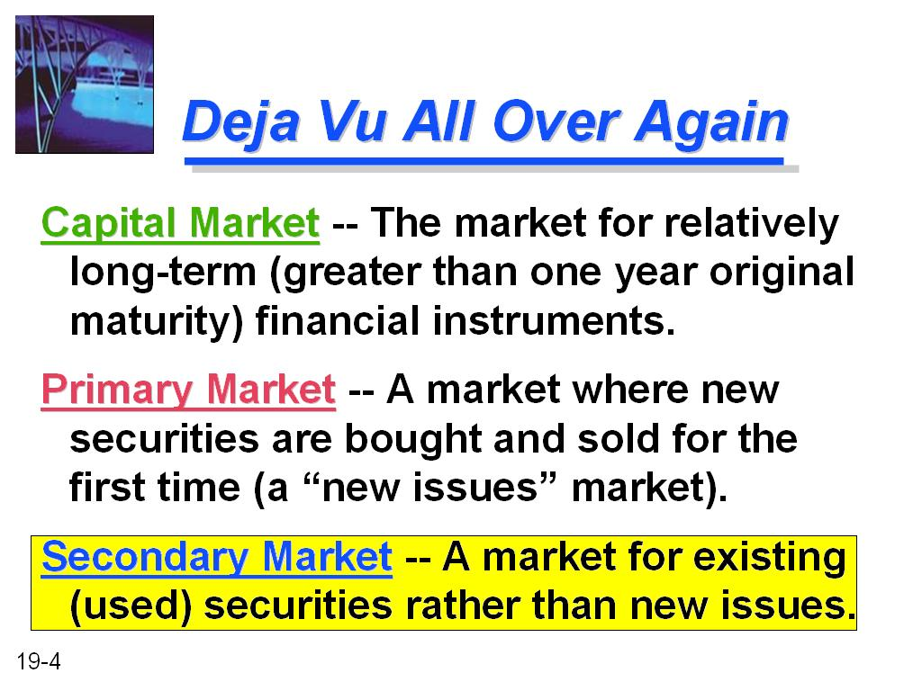

Question No: 22 ( Marks: 1 ) - Please choose one
Which of the following is reflected by the price of a share of common stock?

► Earnings after tax divided by the number of shares outstanding
► The board of directors' assessment of the intrinsic value of the firm
► The book value of the firm's assets less the book value of its liabilities
► The market's evaluation of a firm's present and future performance

Ref:
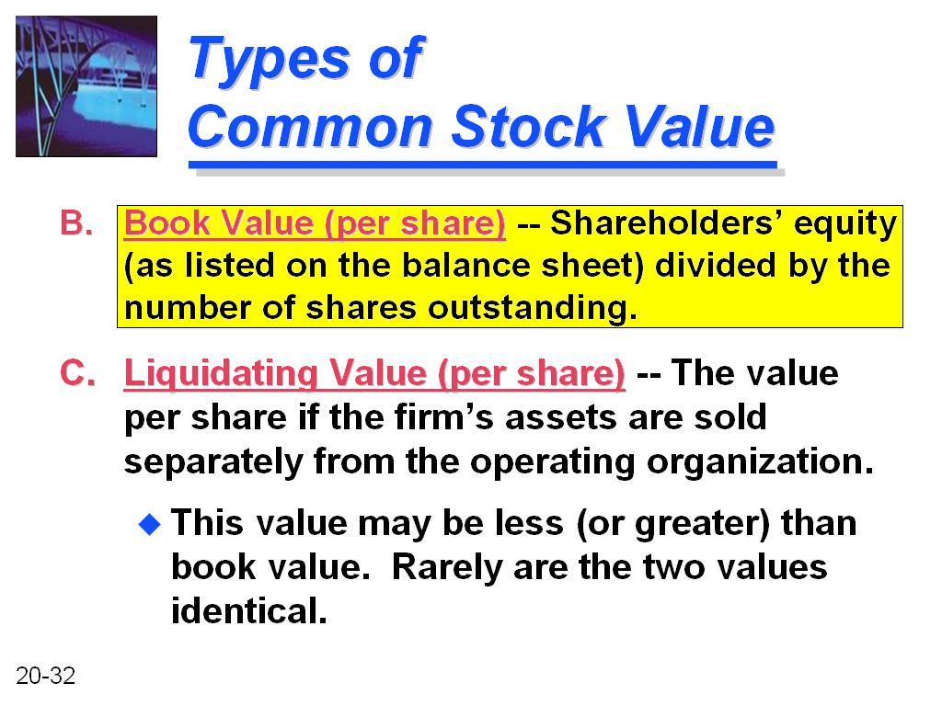
Question No: 23 ( Marks: 1 ) - Please choose one
You are considering buying common stock in Sumi Inc. The firm yesterday paid a dividend of Rs.7.80. You have projected that dividends will grow at a rate of 9% per year indefinitely. If you want an annual return of 24, what should you pay for the stock now?

► Rs.52.00
► Rs.56.68
► Rs.32.50
► Rs.35.43

Question No: 24 ( Marks: 1 ) - Please choose one
Which of the following capital budgeting methods focuses on firm's liquidity?

► Internal Rate of Return
► Payback method
► Net Present Value
► None of the given options
Ref: http://highered.mcgraw-hill.com/sites/0073382388/student_view0/chapter12/multiple_choice_quiz.html

Question No: 25 ( Marks: 1 ) - Please choose one
In deciding the optimal level of current assets for the firm, management is confronted with __________.

► A trade-off between profitability and risk
► A trade-off between liquidity and risk
► A trade-off between equity and debt
► A trade-off between short-term versus long-term borrowing

Ref: PAGE # 101
There are significant funds invested in accounts receivables and there must be some trade off between the profitability and risk. The optimal level of investment should be based on the benefit resulting from a specific level of investment in debtors.
OR see below images
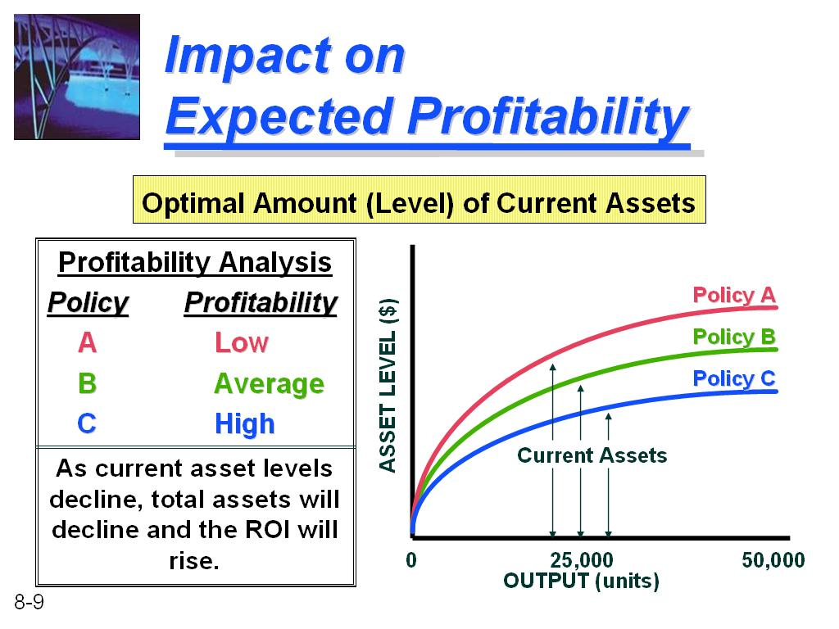
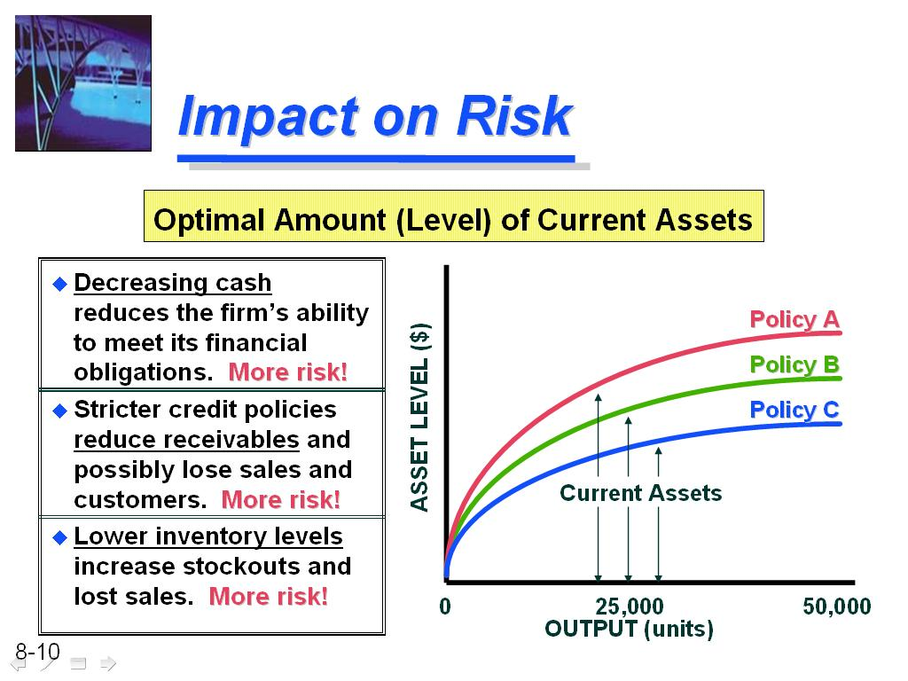
Question No: 26 ( Marks: 1 ) - Please choose one
Mr. Joseph Steve has changed the working capital policy of his company recently. As a result, the liquidity for the company has decreased but an increase in profitability has been observed alongside. From this information we can conclude that the company must have changed his working capital policy from ________ to ________.
► Conservative; Aggressive
► Aggressive; Moderate
► Aggressive; Conservative
► None of the given options
Ref: PAGE # 89

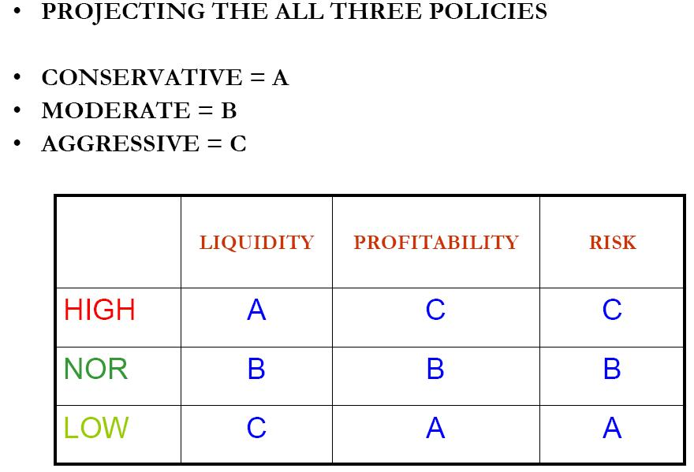

Question No: 27 ( Marks: 1 ) - Please choose one
When the firm considers working capital management, the trade-off between risk and return is affected by all of the followingEXCEPT:

► The pattern of cash borrowing needs of the firm
► The difference between long-term and short-term interest rates
► The ratio of cash to marketable securities
► The debt maturity schedule

Question No: 28 ( Marks: 1 ) - Please choose one
Cash management involves all of the following EXCEPT:

► Efficient disbursement of cash
► Efficient collection of cash
► Wise investment of temporarily surplus cash
► Raising cash through the sale of new stock and bonds

Ref:

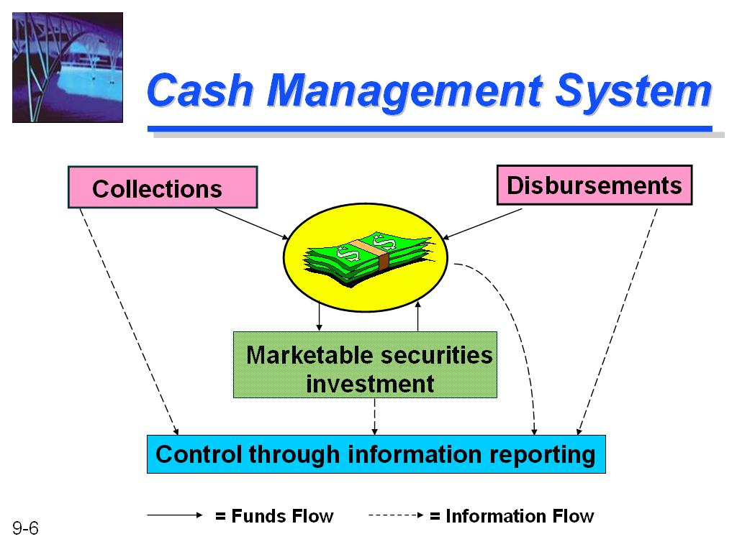

Question No: 29 ( Marks: 1 ) - Please choose one
Which of the following type of customers enjoy comparatively longer credit periods?

► Corporate customers
► Individual customers
► Both corporate and individual customers
► Neither corporate nor individual customers

Ref: PAGE # 102
Customer type:
Corporate customers enjoy longer credit periods compared to individual customers due to their business credibility.

Question No: 30 ( Marks: 1 ) - Please choose one
Total credit cost curve consists of which of the following?

► Total of ordering cost and the opportunity cost of credit policy
► Total of carrying cost and the opportunity cost of credit policy
► Total of opportunity cost of credit policy and the bad debts
► Total of production cost and the cost of credit policy

Ref: PAGE # 105
The total of carrying cost and the opportunity cost of credit policy is called the total credit cost curve. There is a point on the total cost curve where the total credit cost curve is minimized. This point corresponds to the optimal amount of credit or investment in receivables.

Question No: 31 ( Marks: 1 ) - Please choose one
A firm has 30 days collection period and it is offering terms of 2/10, net 30. The estimations shows that around 70% customers will avail this opportunity by paying within 10 days whereas remaining will pay after 30 days. What would be the Average Collection Period (ACP) of the firm?

► 10 days
► 12 days
► 16 days
► 18 days
Ref:
70% x 10 days + 70% x 30 days = 12 days

WORKING:
i)
10 x 70% = 7
Days = 10 – 7 = 3

ii)
30 x 70% = 21
Days = 30 – 21 = 9

Hence, Average Collection Period (ACP) = 9 + 3 = 12 days

Question No: 32 ( Marks: 1 ) - Please choose one
Which of the following statement is CORRECT regarding Conglomerate mergers?

► A firm acquires another firm that is in the same industry but at another stage in the production cycle.
► It occurs when one firm purchases other firms that produce similar or competing products.
► It occurs when unrelated businesses merge.
► None of the given options

Ref: PAGE # 110

Types of Mergers
From the perspective of business structures, there is a whole host of different mergers. Here are a few types, distinguished by the relationship between the two companies that are merging:
Horizontal merger - Two companies that are in direct competition and share the same product lines and markets.
Vertical merger - A customer and company or a supplier and company. Think of a cone supplier
merging with an ice cream maker.
Market-extension merger - Two companies that sell the same products in different markets.
Product-extension merger - Two companies selling different but related products in the same
market.
Conglomeration - Two companies that have no common business areas.

Question No: 33 ( Marks: 1 ) - Please choose one
Which of the following is(are) reason(s) for determining shares value in mergers and acquisitions?

► To set up the terms of takeovers
► To value the company for stock exchange listing
► To value shares – for establishing value of share of retiring directors
► All of the given options

Ref: PAGE # 114
Valuation of shares:
When the consideration of merger transaction has been decided to be settled in shares, then comes the stage to determine the value of share. There are some reasons why we need to value the shares.
- To set up the terms of takeovers
- To value the company for stock exchange listing
- For tax purposes
- To value shares – for establishing value of share of retiring directors

Question No: 34 ( Marks: 1 ) - Please choose one
Value of firm = ___________________________________________

► Value of all equity financed firm + PV of tax benefits + Expected Bankruptcy Costs
► Value of all equity financed firm – PV of tax benefits + Expected Bankruptcy Costs
► Value of all equity financed firm + PV of tax benefits – Expected Bankruptcy Costs
► Value of all equity financed firm – PV of tax benefits – Expected Bankruptcy Costs

Ref: PAGE # 114
Value of firm = Value of all-equity financed firm + PV of tax benefits + Expected Bankruptcy Costs

Question No: 35 ( Marks: 1 ) - Please choose one
Which of the following statements is TRUE regarding the LBO (Leverage Buyout)?

► New common stocks are issued to acquire the firm
► Shareholders’ dividend is used to acquire the firm
► Company’s reserves are used to acquire the firm
► Borrowed money is used to acquire the firm

Ref: PAGE # 124
Leveraged Buyout – LBO
The acquisition of another company using a significant amount of borrowed money (bonds or loans) to meet the cost of acquisition. Often, the assets of the company being acquired are used as collateral for the loans in addition to the assets of the acquiring company. The purpose of leveraged buyouts is to allow companies to make large acquisitions without having to commit a lot of capital.

Question No: 36 ( Marks: 1 ) - Please choose one
Which of the following terms refer to the acquisition of another company using a significant amount of borrowed money (bonds or loans) to meet the cost of acquisition?

► Management Buyout
► Management Buy-In
► Leverage Buyout
► None of the given options

Ref: PAGE # 124
Leveraged Buyout – LBO
The acquisition of another company using a significant amount of borrowed money (bonds or loans) to meet the cost of acquisition. Often, the assets of the company being acquired are used as collateral for the loans in addition to the assets of the acquiring company. The purpose of leveraged buyouts is to allow companies to make large acquisitions without having to commit a lot of capital.

Question No: 37 ( Marks: 1 ) - Please choose one
Which of the following statements is INCORRECT regarding currency future?

► Reversal of currency future is simple.
► Parties have to put an initial margin in currency future.
► The size is pre-determined or fixed in currency future.
► Reversing of currency future requires original parties.

Ref: PAGE # 136

Forward contract vs. Currency future
In currency futures, commodity exchanges are involved and credit risk is eliminated. However, a forward contract is made between parties and each party needs to confirm the credit worthiness of each other. Reversal of currency future is very simple. Large buyers and sellers exist. Reversing forward contract is difficult. Original parties have to set off the deal. Future currency contract become a “commodity” and reversing does not require original parties.

Question No: 38 ( Marks: 1 ) - Please choose one
An option is termed as "out of money" if:

► The exercise price of an option is not favorable than the market price of the underlying item
► The exercise price mentioned in the option is favorable than the market price of the underlying commodity
► The exercise price mentioned in the option is equal to the market price of the underlying commodity
► The exercise price mentioned in the option is above the option cost

Ref: PAGE # 139

Options pricing:
The strike price may be higher, lower or equal to the current market price of underlying item.
For example,
A call option gives the right to its holder to buy x number of shares of y company at Rs 10 per share and the current price could be greater than Rs. 10/-, less than Rs. 10/- or exactly Rs 10/- per share. If the strike price is more favorable than the current market price of underlying asset or item, the option is termed as “in-the-money.” If the strike price is not favorable than the current market price of underlying asset or item, the option is called “out-of-money.” If the strike price and current market price are equal, then it is known as “at-the-money.”

Question No: 39 ( Marks: 1 ) - Please choose one
Short-term Interest Futures (STIRs) are settled through which of the following?

► Cash
► Physical delivery
► Both cash and physical delivery
► Neither cash nor physical delivery

Ref: PAGE # 138

Interest Rate Future:
Interest rate futures are also contracts, which have following features:
- These contracts are similar to currency futures.
- These are traded in standardized form on future exchanges.
- Settlement dates on future exchanges are calendar quarters.
- Each future contract is for standardized quantity of underlying security.
- Price of the future is expressed in terms of underlying item.
- Interest rate future, like currency futures may be settled before the maturity date.
- Short Term Interest Rate futures – STIRs are cash settled.

Question No: 40 ( Marks: 1 ) - Please choose one
An option is termed as “at the money” if:

► The strike price and current market price are equal
► The strike price is higher than current market price
► The strike price is lower than current market price
► None of the given options

Ref: PAGE # 139

Options pricing:
The strike price may be higher, lower or equal to the current market price of underlying item.
For example,
a call option gives the right to its holder to buy x number of shares of y company at Rs 10 per share and the current price could be greater than Rs. 10/-, less than Rs. 10/- or exactly Rs 10/- per share. If the strike price is more favorable than the current market price of underlying asset or item, the option is termed as “in-the-money.” If the strike price is not favorable than the current market price of underlying asset or item, the option is called “out-of-money.” If the strike price and current market price are equal, then it is known as “at-the-money.”

Question No: 41 ( Marks: 1 ) - Please choose one
Which of the following is the CORRECT statement regarding the Law of One Price?

► The law of one price applies to only tradable goods
► The law of one price applies to all goods
► The law of one price applies to immovable goods
► The law of one price applies to services only

Ref: PAGE # 145

There are three caveats with this law of one price.
(1) As mentioned above, transportation costs, barriers to trade, and other transaction costs, can be significant.
(2) There must be competitive markets for the goods and services in both countries.
(3) The law of one price only applies to tradable goods; immobile goods such as houses, and many services that are local, are of course not traded between countries.

Question No: 42 ( Marks: 1 ) - Please choose one
“Companies may be stretching to other countries in search and import to the home country cheap raw materials.” This statement depicts which of the following strategic motives of multinational companies for foreign investment?

► Market development
► Backward integration
► Political safety
► None of the given options

Ref: PAGE # 149
Strategic Motives:
Market Development: A MNC may invest in foreign country in order to expand to new markets. Such companies have very strong product line and have expertise in the field of sales and marketing. Car assembly plants in Pakistan are a good example of market development.
Backward Integration: companies may be stretching to other countries in search and import to the home country cheap raw materials.
Cheap inputs: labor and raw materials in developing countries provide MNCs an opportunity to reduce the cost of sales, as labor is expensive in developed countries. This results in larger profit margin.
Political safety: Political stability and non-interference is what a MNC is looking for. Above all every company will ensure the safety of its investment.

Question No: 43 ( Marks: 1 ) - Please choose one
Which of the following is a mutually controlled entity by two or more business enterprisers having a shared motive?

► Subsidiary
► Branch
► Joint Venture
► Licensing branch

Ref: PAGE # 150

Joint venture:
A jointly controlled entity by two or more venture having a joint motive. Normally one venture comes of local market or country of JV operations. Local venture is considered expert and knowledgeable person as far as local market is concerned. This will help managing the business like obtaining loans, statutory regulation compliance, local laws, taxes etc.

Question No: 44 ( Marks: 1 ) - Please choose one
Between 1870 and 1914, the globally fixed exchange rate was accepted in which the currencies were linked to which of the following?

► Any commodity
► Diamond
► Gold
► Wheat

Ref: Page # 147

Between 1870 and 1914, there was a global fixed exchange rate. Currencies were linked to gold, meaning that the value of a local currency was fixed at a set exchange rate to gold ounces. This was known as the gold standard. This allowed for unrestricted capital mobility as well as global stability in currencies and trade; however, with the start of World War I, the gold standard was abandoned.

Question No: 45 ( Marks: 3 )
Give at least three sources of synergies and explain each of them briefly.
Question No: 46 ( Marks: 5 )
How would you expect the firm’s cash balance to respond to the following changes?
a) Interest rates increase.
b) The volatility of daily cash flow decreases
c) The transaction cost of buying or selling marketable securities goes up
Question No: 47 ( Marks: 5 )
The Inventory Manager of a firm has given the following data:
Consumption per Period = S = 4000 Units
Economic Order Quantity = EOQ = 80 Units
Lead Time = L = 1 Month
Stock out Acceptance Factor = F = 1.10
Requirement:
Determine the Economic Order Point for the firm.
Question No: 48 ( Marks: 5 )
How a firm can create a money market hedge against transaction exposure, when the firm has to make a payment at some future date?
Question No: 49 ( Marks: 10 )
Describe in detail the major steps in short term financial planning process of a firm.
Question No: 50 ( Marks: 10 )
Explain the process of re-organization of a firm in a financial distress.

FINALTERM EXAMINATION
FIN622- Corporate Finance (Session - 3)
Solution is provided by vuZs Solution Team.
You are free to distribute and use it. In case you wanted to host or re-distribute it. Please don’t remove the links of group and website.

Time: 120 min

Question No: 1 ( Marks: 1 ) - Please choose one
Which of the following is an expected rate of return on a bond if bought at its current market price and held to maturity?

► Yield to maturity
► Current yield
► Coupon yield
► Capital gains yield

Ref: PAGE # 18
Yield to Maturity:
The yield to maturity (YTM), is the discount rate which returns the market price of the bond. It is thus the internal rate of return of an investment in the bond made at the observed price. YTM can also be used to price a bond, where it is used as the required return on the bond.
OR
http://web.utk.edu/~jwachowi/mcquiz/mc4.html

Question No: 2 ( Marks: 1 ) - Please choose one
A firm can lower its breakeven level by doing which of the following actions?

► Lowering direct cost
► Increasing variable cost
► Increasing direct cost
► Lowering sales price

Ref: PAGE #39
Ways to Lower Break-Even:
There are three ways to lower your break-even volume, only two of them involve cost controls (which
should always be your goal on an ongoing basis).
1. Lower direct costs, which will raise the gross margin. Be more diligent about purchasing material,controlling inventory, or increasing the productivity of your labor by more cost effective scheduling or adding more efficient technology.
2. Exercise cost controls on your fixed expense, and lower the necessary total dollars. Be careful when cutting expenses that you do so with an overall plan in mind. You can cut too deeply as well as too little and cause distress among workers, or you may pull back marketing efforts at the wrong time, which will give out
the wrong signal.
3. Raise prices! Most entrepreneurs are reluctant to raise prices because they think that overall business will fall off. More often than not that doesn’t happen unless you are in a very price-sensitive market, and if you are, you really have already become volume driven.

Question No: 3 ( Marks: 1 ) - Please choose one
Which one of the following statements applies to Dividend Growth Model?

► It is difficult to understand and use
► It is used for non-listed companies
► It is used for debt securities also
► It do not consider risk level of a security

Ref: PAGE # 60
This approach does not take into account the risk level. There is no direct adjustment for the risky ness of the investment. For instance, there is no adjustment for the degree of certainty or uncertainty in estimated growth rate for dividends

Question No: 4 ( Marks: 1 ) - Please choose one
Which of the following refers to a stock issuance process where a company offers its shares to a limited number of investor?
► Initial Public Offering
► Private Placement
► Direct Public Offering
► Primary Offering

Ref:
The sale of securities to a relatively small number of select investors as a way of raising capital. Investors involved in private placements are usually large banks, mutual funds, insurance companies and pension funds. Private placement is the opposite of a public issue, in which securities are made available for sale on the open market

OR

http://www.investopedia.com/terms/p/privateplacement.asp

Question No: 5 ( Marks: 1 ) - Please choose one
Which of the following is the principal advantage of high debt financing?

► Tax savings
► Low Bankruptcy costs
► Minimum financial risk
► Low financial leverage
Ref: Page # 72
M & M model says that debt financing increases the value of firm due to tax shield.

Question No: 6 ( Marks: 1 ) - Please choose one
Which of the following firms would have the highest financial leverage?

► A firm having debt-to-equity ratio of 30:70
► A firm having debt-to-equity ratio of 40:60
► A firm having debt-to-equity ratio of 50:50
► A firm having debt-to-equity ratio of 60:40
Ref:
In above McQ Debt = 60 and Equity = 40
Financial Leverage
The amount of debt in capital structure of a firm is known as financial leverage. In other words, how a firm utilizes the amount of debt. The more debt in capital structure, there is greater financial leverage.
The debt-to-equity ratio is total debt divided by total equity:
Debt-to-Equity Ratio = Total Debt/Total Equity

Question No: 7 ( Marks: 1 ) - Please choose one
In which of the following dividend policies, the amount of dividend is relatively fixed?

► Constant payout ratio policy
► Hybrid dividend policy
► Residual dividend policy
► Stable dividend policy

Ref:

A constant payout ratio policy is a policy of paying a FIXED percentage of a firm’s earnings as dividends in each period. Such a policy is likely to result in wildly fluctuating dividends. As a result, only a small percentage of dividend paying firms follow such a policy

Question No: 8 ( Marks: 1 ) - Please choose one
Which of the following serves as a starting point for preparing functional budgets of a firm?

► Sales budget
► Master budget
► Production cost budget
► Cash budget
Ref:

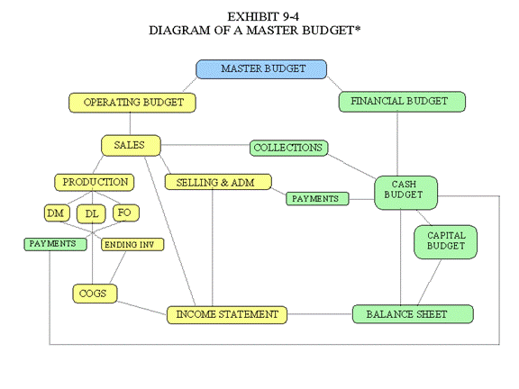
The master budget has two major parts including the operating budget and the financial budget (See Exhibit 9-4). The operating budget begins with the sales budget and ends with the budgeted income statement. The financial budget includes the capital budget as well as a cash budget, and a budgeted balance sheet

Question No: 9 ( Marks: 1 ) - Please choose one
A company is holding cash as a buffer in case of an unexpected need with operations. This is an example of the ________ motive for holding cash.

► Precautionary
► Speculative
► Transactions
► Capital needs
Ref: PAGE # 94
Motives for Cash holding
Transactions Motive ensures that the firm has enough funds to transact its routine, day-to-day business affairs. Safety Motive protects the firm against being unable to meet unexpected demands for cash. Speculative Motive allows the firm to take advantage of unexpected opportunities that may arise
Note:
Precautionary = Safety Motive
OR
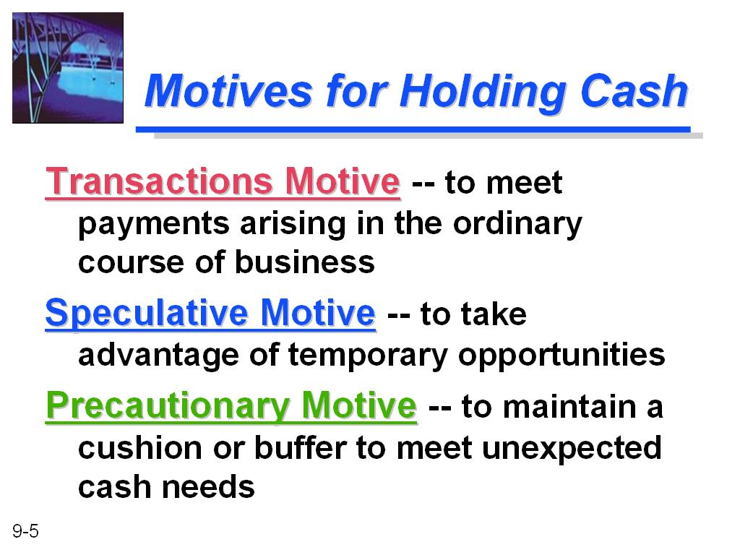

Three Motives for Holding Cash

In his publication on The General Theory of Employment, Interest, & Money, Keynes outlined three reasons, or motives, for holding money or cash:
Transaction Motive - cash is held to pay for goods or services. It is useful for conducting our everyday transactions or purchases.
Precautionary Motive - cash is a relatively safe investment. Cash investments rarely lose value (as can stocks or bonds) and are therefore held for safety reasons in a balanced portfolio.
Asset or Speculative Motive - cash investments provide a return to their holders.
http://www.money-zine.com/Investing/Investing/Holding-Cash/

OR

Below reference is provided by IJAZ
http://www.theglobaltutors.com/Homework-Help/subjects.aspx?topic=575&cateid=19

Question No: 10 ( Marks: 1 ) - Please choose one
Which of the following is an "income based method" for share valuation of a target firm?

► Replacement cost method
► Break up value method
► Dividend valuation method
► Accumulated depreciation method

Ref: PAGE #115
We may employ following valuation methods for unquoted shares. We divide them into two Broad categories:
Income based approach:
- Present value method
- Dividend valuation
- P/E ratio

Question No: 11 ( Marks: 1 ) - Please choose one
Which of the following is a re-structuring strategy in which employees buy a majority share in their own firm?

► Employee Dividend Scheme
► Employee Buyout
► Employee Empowerment
► Leverage Buyout

Ref: PAGE # 124
Employee Buyout – EBO
A restructuring strategy in which employees buy a majority stake in their own firms. This form of buyout is often done by firms looking for an alternative to a leveraged buyout. Companies being sold can be either healthy companies or ones that are in significant financial distress.

Question No: 12 ( Marks: 1 ) - Please choose one
All of the following could be the reasons for a subsidiary buyout EXCEPT:

► The parent company is in financial distress
► The parent company needs cash
► The parent company prefers to sell the firm rather that liquidation
► The parent company wants liquidation

Ref: PAGE # 124
The existing parent company of the victim firm may wish to dispose of it. The parent company may be caught up in financial distress and is in acute need of cash and liquidity. The subsidiary on the other hand, is not strategically fit with parent’s overall business strategy.

Question No: 13 ( Marks: 1 ) - Please choose one
A firm has to pay $10,000 to an American company after three months. The firm enters into a contract with a foreign exchange dealer to buy $10,000 after three months at Rs.61/US$. This contract would be beneficial for the firm if:

► After three months the exchange rate is Rs.60/US$
► After three months the exchange rate is Rs.61/US$
► After three months the exchange rate is Rs.62/US$
► After three months the exchange rate is Rs.59/US$

Ref:
Explanation
A company enters into a contract to buy x dollars after 3 months at an exchange rate of Rs 61/ US $ decided now. At the maturity date both parties have to honor their respective commitments of buying and selling of US $ at agreed rates.
Now if on the maturity date,
the spot ex rate is Rs 62/US $, (PKR weakened against US $), then the company has actually eliminated the loss and benefited financially.
However, if the spot rate on maturity date is Rs. 60/US $, (contrary to its estimation of weak local currency, local currency strengthened) then the company has missed the opportunity to benefit from this favorable sport rate.

Question No: 14 ( Marks: 1 ) - Please choose one
A firm can fix effective interest rate on short-term borrowings by doing which of the following?

► Buying a forward rate agreement
► Selling a forward rate agreement
► Borrowing local currency
► Borrowing base currency

Ref: PAGE # 137
Forward rate agreement(FRA)
FRA offer companies the facility to fix future interest today either on short-term borrowing or deposit for an agreed future period.
An effective interest rate can be fixed on future short-term borrowing by buying an FRA.
Alternatively,
an effective interest rate can be fixed on short-term deposit or investment by selling FRA.

Question No: 15 ( Marks: 1 ) - Please choose one
A firm can fix effective interest rate on its short-term investment to be made at some future date by doing which of the following?

► Borrowing local currency
► Borrowing base currency
► Selling a forward rate agreement
► Buying an forward rate agreement

Ref: PAGE # 137
Forward rate agreement(FRA)
FRA offer companies the facility to fix future interest today either on short-term borrowing or deposit for an agreed future period.
An effective interest rate can be fixed on future short-term borrowing by buying an FRA.
Alternatively,
an effective interest rate can be fixed on short-term deposit or investment by selling FRA

Question No: 16 ( Marks: 1 ) - Please choose one
A company may create a hedge through interest rate futures if it intends to make some investment for a short-term at some future date, because of:

► Fall in short-term interest rates
► Fall in short-term deposit rates
► Increase in short-term interest rates
► Increase in short-term deposit rates

Ref: PAGE # 139
The hedge can be created by buying short-term interest future. Future position should be closed when actual deposit period begins by selling the same number of interest rate futures.

If interest rate rise, price will fall, loss will incur.

If interest rate fall, price will rise, profit will be generated.

Question No: 17 ( Marks: 1 ) - Please choose one
Which one of the following statements is CORRECT regarding Option?

► An option creates an obligation for the holder
► An option creates a right and not the obligation for the holder
► Option seller is the option holder
► Option writer is the option holder

Ref: PAGE # 139

Options:
An option is a contract that confers a right to buy or sell a specific quantity or asset – but not the obligation, at agreed price on or before the specified future date.

Question No: 18 ( Marks: 1 ) - Please choose one
Which one of the following statements is CORRECT regarding Options Contacts?

► A put option gives the holder a right to sell underlying item at a specified price
► A put option gives its writer the right to sell underlying item at a specified price
► A call option gives its writer a right to sell underlying item
► A call option gives its holder a right to sell underlying item

Ref: PAGE # 139

Features of Options:
· It is a contractual agreement.
· The holder of option exercises his/her right only if it is in his/her favours.
· Option writer is seller and must honor his side of contract. (Sell or buy at agreed price).
· Options like futures are standardized transaction in terms of size & duration.
· Options are Exchange traded
· These agreements are easy to buy & sell
· Options either are call options or put options.
· The option purchase price is called option premium.
· Call option gives its holder a right (not obligation) to buy underlying item at the specified price.
· Put option gives its holder a right (not obligation) to sell underlying item at specified price.

Question No: 19 ( Marks: 1 ) - Please choose one
Which of the following could be used as a hedging tool against unfavorable movement in interest rate?

► Currency option
► Currency futures
► Interest rate option
► Currency SWAP

Ref: PAGE # 143

Interest Rate Caps and Floor
Firms may borrow from a bank or deposit funds at variable rate of interest connected to some benchmark rate like KIBOR in Pakistan or LIBOR (London Inter Bank Offered Rate) in international money markets. When borrowing on variable interest rates, a firm may want to utilize option as hedging tool against the unfavorable interest rate movements over the full term of loan or deposit

Question No: 20 ( Marks: 1 ) - Please choose one
The credit policy of a public company is 1/10, net 30. At present 25% of the customers take the discount. What would accounts receivable be if all customers took the cash discount?

► Account receivable would be lower than the present level
► No change from the present level
► Account receivable would be higher than the present level
► Unable to determine without more information

Ref:
Example
term of “1/10, net 30” means that discount of 1% is available only if the payment is received within first ten days of delivering goods otherwise, full invoice value will be payable by the debtor on 30th day. There’s a cost of credit for seller. By availing a discount for early payment the buyer is often not in all position to ignore the cash discount.

Question No: 21 ( Marks: 1 ) - Please choose one
In the long run, a successful acquisition is one that:

► Enables the acquirer to make an all-equity purchase, thereby avoiding additional financial leverage
► Enables the acquirer to diversify its asset base
► Increases the market price of the acquirer's stock over what it would have been without the acquisition
► Increases the financial leverage of the firm

Ref:
Increased revenue or market share: This assumes that the buyer will be absorbing a major competitor and thus increase its market power (by capturing increased market share) to set prices.

http://en.wikipedia.org/wiki/Mergers_and_acquisitions

Question No: 22 ( Marks: 1 ) - Please choose one
The efficiency enhancing effect resulting from a strategic merger is called which of the following?

► Merger effect
► Acquisition effect
► Synergy effect
► Efficiency effect

Ref: Page # 108

Synergy is the magic force that allows for enhanced cost efficiencies of the new business. Synergy takes the form of revenue enhancement and cost savings.

Question No: 23 ( Marks: 1 ) - Please choose one
How much debt financing is used by a firm whose beta is un-geared?

► 100% debt financed
► 100% equity financed
► 50% equity and 50% debt financed
► 60% equity and 40% debt financed

Ref: PAGE # 66

Example:
We need to un-gear the beta. Why? Note that the beta of the industry in which the proposed project falls has D/E ratio of 40:60 but the new project shall be all equity financed. We un-gear the beta – that means the financial risk element needs to be removed from the geared beta

Question No: 24 ( Marks: 1 ) - Please choose one
Which of the following is more appropriate to use while comparing investment alternatives with different compounding periods?

► Quoted Interest Rate
► Annual Percentage Rate
► Effective Annual Interest Rate
► Nominal Interest Rate

Ref: Page # 15
Effective Annual Rate – EAR
The Effective Annual Rate (EAR) is the interest rate that is annualized using compound interest. The EAR is the annualized equivalent of interest with shorter compounding periods.
It can be calculated from the following formula:
EAR = (1 + i/n) n - 1

Question No: 25 ( Marks: 1 ) - Please choose one
An investor would be exposed to which of the following risks, if he may have to sell a bond prior to maturity and interest rates have risen since the bond was purchased?

► The coupon effect risk
► Interest rate risk
► Inflation risk
► Unique risk

Ref: Page # 136

If a company is planning to borrow at variable rate of interest, the interest amount charged each time varying according to whether short-term interest rates have risen or fallen since the previous payment. To quote another example how interest rate fluctuations affect the financials of the company, a company may have invested in bonds and any change in interest rate will affect the value of investment in balance sheet.
Examples of interest rate risk – short term investments, investment in bonds, borrowings in short term – variation in short term interest rate.

Question No: 26 ( Marks: 1 ) - Please choose one
Which of the following focuses on long-term investment decision-making process?

► Working Capital Management
► Capital Budgeting
► Cash Budgeting
► None of the given options

Ref: PAGE # 24
Capital budgeting:
Capital Budgeting is the planning process used to determine a firm's long term investments such as new machinery, replacement machinery, new plants, new products, and research and development projects. Capital budgeting process is carried out for projects involving heavy initial upfront cost.

Question No: 27 ( Marks: 1 ) - Please choose one
According to the reinvestment rate assumption, which method of capital budgeting assumes that the cash flows are reinvested at the project's rate of return?

► Payback period
► Net present value
► Internal rate of return
► None of the given options

Ref: PAGE # 27
Net present value (NPV)
There are two aspects of NPV method of project evaluation. First is the initial investment or upfront cost and second, is the benefits (like cash flow) emerging from the project. First aspect is pretty simple. As it is incurred in the current or present time, there are no issues associated with its measurement. On the other side, benefits shall be reaped in future and involves time value of money, making the measurement complex and difficult.

Question No: 28 ( Marks: 1 ) - Please choose one
Which of the following statements is correct for a project with a positive Net Present Value (NPV)?

► Internal rate of return (IRR) exceeds the cost of capital
► Accepting the project has an indeterminate effect on shareholders
► The discount rate exceeds the cost of capital
► The profitability index equals one

Ref: PAGE # 29

Question No: 29 ( Marks: 1 ) - Please choose one
While calculating cash flow from operating activities through indirect method, an increase in current assets is __________ whereas an increase in current liabilities is ___________ net income?

► added to; added to
► added to; deducted from
► deducted from; added to
► deducted from; deducted from

Ref: PAGE # 83 Cash flow Performa

OR below image

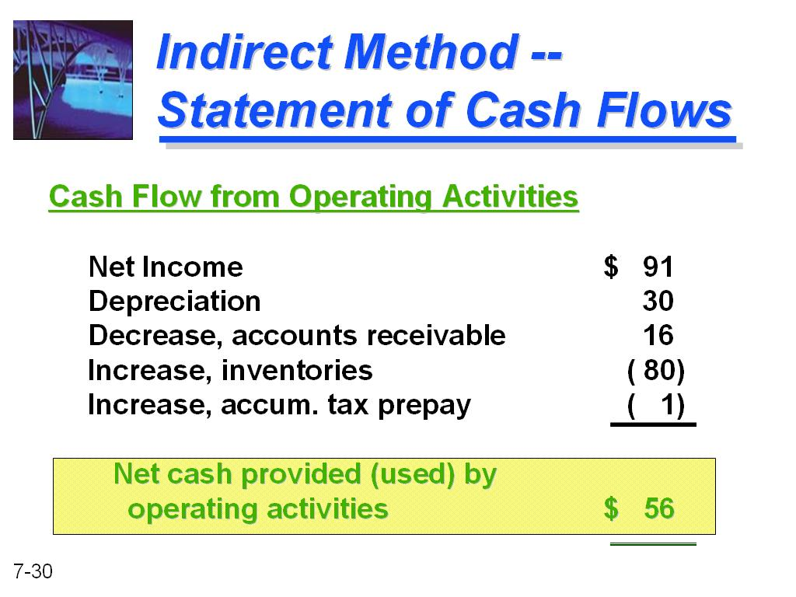

Question No: 30 ( Marks: 1 ) - Please choose one
Which of the following holds true regarding aggressive working capital policy?

► High liquidity; high profitability; high risk
► High liquidity; low profitability; low risk
► Low liquidity; low profitability; high risk
► Low liquidity; high profitability; high risk

Ref: PAGE # 89

Question No: 31 ( Marks: 1 ) - Please choose one
Which of the following holds TRUE regarding conservative working capital policy?

► High liquidity; high profitability; high risk
► High liquidity; low profitability; low risk
► Low liquidity; low profitability; high risk
► Low liquidity; high profitability; high risk

Ref: PAGE # 89

Question No: 32 ( Marks: 1 ) - Please choose one
“The firm has very little net working capital sometimes even negative net working capital that can be very risky.”
The above statement belongs to:

► Aggressive working capital policy
► Conservative working capital policy
► Moderate working capital policy
► The statement is not related to any of the working capital policies

Ref: PAGE # 88

AGGRESSIVE WORKING CAPITAL POLICY;
– Low level of investment
– More short-term financing is used to finance current assets.
– Support low level of production & sales
– Borrowing short-term is considered more risky than borrowing long-term.
– Firm risk increases, due to the risk of fluctuating interest rates, but the potential for higher
Returns increases because of the generally low-cost financing.
– This approach involves the use of short-term debt to finance at least the firm’s temporary
assets, some or all of its permanent current assets, and possibly some of its long-term fixed
assets. (Heavy reliance on short term debt)
– The firm has very little net working capital. It is more risky.
– May be a negative net working capital. It is very risky

Question No: 33 ( Marks: 1 ) - Please choose one
“The firm has a reasonable amount of net working capital that leads to a low-risk position”.

The above statement belongs to:
► Aggressive working capital policy
► Conservative working capital policy
► Moderate working capital policy
► The statement is not related to any of the working capital policies

Ref: PAGE # 88

CONSERVATIVE WORKING CAPITAL POLICY;

– High level of investment in current assets
– support any level of sales and production
– High liquidity level
– Avoid short-term financing to reduce risk, but decreases the potential for maximum value
Creation because of the high cost of long-term debt and equity financing.
– Borrowing long-term is considered less risky than borrowing short-term.
– This approach involves the use of long-term debt and equity to finance all long-term fixed
Assets and permanent assets, in addition to some part of temporary current assets.
– The firm has a large amount of net working capital. It is a relatively low-risk position.
– The safety of conservative approach has a cost.
– Long-term financing is generally more expensive than short-term financing.

Question No: 34 ( Marks: 1 ) - Please choose one
Financial data for three firms is presented below. Each differs only with respect to philosophy on an aggressive vs. a conservative approach to current asset management.

FIRM A FIRM B FIRM C
Sales Rs.2,000,000 Rs.2,000,000 Rs.2,000,000
EBIT 200,000 200,000 200,000
Current Assets 600,000 500,000 400,000
Fixed Assets 500,000 500,000 500,000
Total Assets 1,100,000 1,000,000 900,000
What will be the rate for the firm with the most aggressive philosophy?

► 18.2 percent
► 33.3 percent
► 25.5 percent
► 22.2 percent

Question No: 35 ( Marks: 1 ) - Please choose one
Which of the following is equal to Stock out cost?

► Carrying cost Safety stock
► Holding cost Carrying cost
► Reordering cost Safety stock
► Carrying cost Reordering cost

Ref: PAGE # 100
Doubt in answer for further confirmation see PAGE#100

Question No: 36 ( Marks: 1 ) - Please choose one
Which of the following statement is INCORRECT regarding Just-In-Time (JIT)?

► The inventories are kept near zero level.
► The inventory is acquired in such quantity on daily basis that can support the daily production level.
► The entire inventory acquired move to the production hall.
► Inventory level is necessarily kept at zero level.

Ref: PAGE # 100
Just In Time (JIT):
The idea explains that inventories are kept near zero level. This means that inventory is acquired in such
quantity on daily basis that can support the daily production level. Therefore, there’s no inventory lying in
store room rather all the inventory acquired move to production hall.
The philosophy is to pull inventory through the production processes on as “as-needed” basis rather than
pushing inventory through the processes on an “as-produces basis”. This requires extreme accurate
estimates and there no chance of an error. For example, there’s a high probability of running out of stock
and that could be disastrous.
JIT does not necessarily mean zero inventory level. The objective is to minimize the inventories but to
increase the productivity, quality and flexibility.

Question No: 37 ( Marks: 1 ) - Please choose one
Which of the following type of mergers occurs when one firm purchases other firms that produce similar or competing products?

► Horizontal
► Vertical
► Financial
► Conglomerate

Ref: PAGE # 109

Horizontal merger:
Two companies that are in direct competition and share the same product lines and markets.

Question No: 38 ( Marks: 1 ) - Please choose one
Which of the following valuation approach allows for specific and direct estimation of future benefits to the owners, which is consistent with the theory of value?

► Asset-based method
► Income-based method
► Hybrid method
► None of the given options

Ref: PAGE # 119
Hybrid Methods
The income and asset-based approaches to valuation have relative strengths as well as obvious limitations.
example,
the income approach allows for specific and direct estimation of future benefits to the owners, which is consistent with the theory of value.

Question No: 39 ( Marks: 1 ) - Please choose one
The experts hired in evaluation stage of a public take over process DO NOT include which of the following?

► Legal consultants
► Accountants
► Shareholders
► Stock Brokers

Ref: PAGE # 119
Acquisition Procedures:
• Procedure for public takes over:
• Growth / expansion is decided
• Predator company appoints experts – legal consultants, banks, accountants and stock brokers
• Decision regarding contact with target firm – approach before the bid or hostile takeover
• Purchase of certain % age of shares of target
• Establish an offer and communicate target
Includes offer document, offer validity, predator may revise offer if declined by target
• Acquisition of private company:
• Limited consultancy services from expert are required. internal evaluation is normally enough.
• Detailed investigation is conducted before the transaction.
• Offer price is negotiated by both parties
• Finalization of deal by entering into a contract
• Payment of price finishes the deal.

Question No: 40 ( Marks: 1 ) - Please choose one
In which of the following forms of acquisition, a company's existing managers acquire a large part or all of the company?

► Management Buyout
► Management Buy-In
► Leverage Buyout
► None of the given options

Ref: PAGE # 123

Management Buyouts
Management buyouts are similar in all major legal aspects to any other acquisition of a company. The particular nature of the MBO lies in the position of the buyers as managers of the company and the practical consequences that follow from that. In particular, the due diligence process is likely to be limited as
the buyers already have full knowledge of the company available to them. The seller is also unlikely to give any but the most basic warranties to the management, on the basis that the management knows more about the company than the sellers do and therefore the sellers should not have to warrant the state of the company. In many cases, the company will already be a private company, but if it is public then the management will take it private.

Question No: 41 ( Marks: 1 ) - Please choose one
Recession in economy is related to which of the following levels of financial distress of a firm?

► Firm Level
► Industry Level
► Macro-Level
► All of the given options

Ref: PAGE # 127
We can divide the sources of financial distress into three categories:
a- Firm level causes of financial distress
b- Industry level causes
c- Macro level factors causing financial distress

Question No: 42 ( Marks: 1 ) - Please choose one
Which of the following would be the outcome if the fixed rate in the forward rate agreement (FRA) is lower than the reference rate?

► The seller of the FRA makes a cash payment to the buyer.
► Both buyer and seller make payments to each other.
► The buyer of the FRA makes a cash payment to the seller.
► Neither buyer nor seller makes any payment to each other.

Ref: PAGE # 137

Decision Rule:
When a FRA reaches its maturity – the settlement date, both the seller and buyer must settle the contract. If the fixed rate in the agreement is higher than the reference rate (may be KIBOR), the buyer of the FRA makes a cash payment to the seller. The payment is for the amount by which the FRA rate exceeds the
reference rate. If the fixed rate in the agreement is lower than the reference rate, the seller of the FRA makes a cash payment to buyer – exactly the reverse of above. The payment is for the amount by which the FRA rate is less than the reference rate.

Question No: 43 ( Marks: 1 ) - Please choose one
If the strike price and current market price are equal, an option would be termed as:

► In the money
► Out of money
► At the money
► None of the given options

Ref: PAGE # 139

Options pricing:
The strike price may be higher, lower or equal to the current market price of underlying item.
For example,
a call option gives the right to its holder to buy x number of shares of y company at Rs 10 per share and the current price could be greater than Rs. 10/-, less than Rs. 10/- or exactly Rs 10/- per share. If the strike price is more favorable than the current market price of underlying asset or item, the option is termed as “in-the-money.” If the strike price is not favorable than the current market price of underlying asset or item, the option is called “out-of-money.” If the strike price and current market price are equal, then it is known as “at-the-money.”

Question No: 44 ( Marks: 1 ) - Please choose one
Which of the following theories states that exchange rates between currencies are in equilibrium when their purchasing power is the same in each of the two countries?

► M&M theory
► Purchasing Power Parity theory
► Fisher effect theory
► Interest rate risk theory

Ref: PAGE # 145

Purchasing Power Parity Theory:
Purchasing power parity (PPP) is a theory, which states that exchange rates between currencies are in equilibrium when their purchasing power is the same in each of the two countries. This means that the exchange rate between two countries should equal the ratio of the two countries' price level of a fixed basket of goods and services. When a country's domestic price level is increasing (i.e., a country experiences inflation), that country's exchange rate must depreciated in order to return to PPP.

Question No: 45 ( Marks: 3 )
How firms analyze their credit policies? Explain briefly.
Question No: 46 ( Marks: 5 )
How Economic Order Quantity (EOQ) Model is helpful in the reduction of total inventory costs?
Question No: 47 ( Marks: 5 )
Differentiate between Spot Rates and Forward Rates of currencies. Why forward rates are higher than spot rates?
Question No: 48 ( Marks: 5 )
How a firm can create a money market hedge against transaction exposure, when the firm has to make a payment at some future date?
Answer: .
Question No: 49 ( Marks: 10 )
A Firm sales 200,000 units per year of a particular Product, order size is for 5000 units and stock out is 3000 units. The stock out probability acceptance level is set to 5% and per unit stock out cost is Rs.7/-. Holding cost is estimated at Rs.3/- per unit. Being an inventory manager, determine stock out cost and amount of safety stock to be kept in hand.
Question No: 50 ( Marks: 10 )
Why firms do business internationally? Explain in detail.

