 | Assignment No. 03  Semester: Spring 2015  Visual Programming-CS411 | Total Marks: 20  Due Date: 29/Jul/2015
Instructions:
Please read the following instructions carefully before submitting assignment:
- You will submit your assignment before or on due date on VU-LMS.
- Assignment should be completed by your own efforts it should not be copied from internet, handouts or books.
- You should submit your .doc File via assignment interface at VU-LMS.
- Assignment sent via Email will not be replied and accepted in any case.
- If the submitted assignment does not open or file is corrupt, it will not be marked.
- You will submit solution only in document (.doc or .docx) File.
Objectives:
To build the programming practices and understandability of localization in WPF applications.
For any query about the assignment, contact at cs411@vu.edu.pk
Assignment Questions
Question: Marks 20

Localization is the best methodology to improve your product for global audience and to remove the product’s availability for limited users. So you are requested to create a localizable WPF application by using the grid in an automatic layout approach. Insert some buttons and texts to this grid with “Auto” height and width; therefore cells that contain the image are adjustable to fit the image. This automatic layout approach can demonstrate the localizable application. The output of your application should be same as the following window.

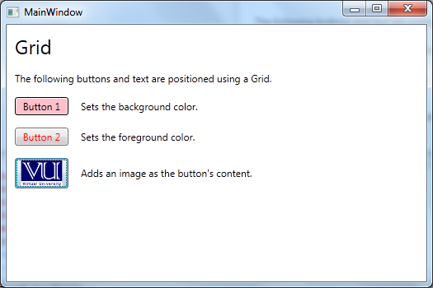

BEST OF LUCK

